# **Missionary Partner Update May 2024**

Carolyn

Janie

# world_600w.jpg

Satish & Bhumika

Kramers

Craig & Amanda

Bernard

Morven ND

James

****Bernard Bakunda, Uganda**

**Appreciation**

I thank God for the way He brought us to be partners with Burnside Church in 1984. I deeply appreciate the financial and prayer support you have given us during the forty years of our partnership.

**Ministry and Family**

In February 1984 Alice and I were in a difficult situation. We were living a life of uncertainty, having married when her right arm had just been amputated due to gunshots in our country.  At that time, I was responsible for leading the Uganda Healthcare Christian Fellowship and I did not know how I would cope. It was then, when the leadership of Burnside Church empathetically stood with us and have continued supporting us to this day!

In 2002 I was ordained to the ministry in the Church of Uganda and served as a hospital chaplain, then a university chaplain until 2012 when I was made a vicar until I retired in 2017. Alice, a woman of great courage changed career from Nursing and trained as a Clinical Psychologist. She taught counselling at the university until God promoted her to glory on 2nd March 2022. This was after 37 years of our happy marriage.

God blessed us with our daughter Faithful who studied Environmental Sciences and is married to Abel a designer. Our son Timothy, is a medical doctor working at Mengo hospital and married Deborah in August 2023. Peter our youngest is an Engineer and married Sonia in 2021. Gerald is another young man we brought up; he is an Economist and is also married. I still have 3 boys who stay with me: Stephen 13yrs, Jonan (12yrs) and Jeremiah (10) yrs. I also have two young men Inocent and Enoch who assist me with house chores.

**RHEMA SCHOOL**

I retired from Church Ministry at 65yrs to focus on nurturing the children at Rhema school. We started the school in 2002 with one teacher and 12 children in a small room. Today, God has blessed us with a multi-storey school, **15 teaching staff**, **3 non teaching** staff and over **300 children**. My responsibility, with God’s help, is to teach these children the way of God.

**ROMAN  PROJECT**

Along with a young pastor called Simon, I am involved in mobilizing church ministers to read St. Paul's Letter to the Romans twenty times and to hand copy it. The project takes at least 12 months. Though it is hard work, it is rewarding.

**BOOK WRITING**

In 2023, the Holy Spirit prompted me sit down and write a story about Alice which I called **A Woman of Excellence**! It is an encouraging book to read. Writing Alice's testimony, up-lifted me. Instead of grieving, I ended up rejoicing in the hope we have in Christ. This year 2024, I am working on another book on Discipleship.

**CHAPLAINCY MINISTRY**

I praise God for giving me energy and strength to keep busy throughout the week. I always find myself being invited to share in chaplaincy ministry both in hospitals and in schools. Yet, my strength is renewed every day.

Please pray

* for Bernard and the family
* for children and staff at Rhema school
* for Bernard as he continues to minister in churches and at conferences

**Carolyn Tomasović, Croatia** [www.eiz.hr](http://www.eiz.hr)

Carolyn grew up in Burnside and is a member of Burnside Blairbeth church. She has been living and working in Croatia for over 30 years. Carolyn and Miro have 3 adult children. A graduate of the Glasgow School of Art, Carolyn first travelled to the region via a scholarship to the Academy of Fine Art in Zagreb in 1989. After returning in 1992 to visit friends, the war disrupted travel and she remained, volunteering with numerous aid agencies and churches. Her professional life has taken many diverse turns from artist to the UN military peacekeeping forces serving in ex-Yugoslavia to field consultant for the World Council of Churches for whom she managed two regional funds for 15 years. She has lived and worked in the region throughout the wars where, among a variety of activities, she cooperated with the Conference of European Churches in facilitating the inter-religious roundtables for ex-Yugoslavia in the 1990s. In 2008 Caroyn established and continues to run the Ecumenical Women's Initiative (EWI), a Croatian women's organisation active in Bosnia & Herzegovina, Croatia, Kosovo, North Macedonia, Montenegro and Serbia, supporting grassroots women’s peace activism within an interfaith framework. The aim of the organisation is to strengthen the role of women in local and regional peacebuilding processes through the promotion, development and advancement of women’s human rights, non-violence and inter-religious/ethnic dialogue. They do this by inviting women-led organisations and groups to submit their proposals which they assess and if everything is in place, they provide a grant and support the initiative. In this way,EWI seeks to empower women and girls as essential actors for social change towards sustainable, positive peace, and in the potential of faith, for the restoration of trust in building peace and reconciliation processes. Carolyn has commented that in her experience, when women develop their own responses, lead innovative actions, and become spokespersons standing up for injustice on behalf of the wider community, other women are inspired and motivated to act, and public perception of women is changed.

EWI promotes the affirmation of its values and respect of others as a precondition to peaceful coexistence in which human potential is developed through solidarity, inclusion and cooperation, and the constructive transformation of conflict. To date EWI has supported 700 women-led initiatives across the region which have directly impacted the lives of over 65,000 people. Carolyn and her team also facilitate meeting opportunities for women to come together from across the region to meet, share and develop common actions such as one which brought together women theologians from the Abrahamic religions and another which brought together peace activists to reflect on the growing militarism in Europe and what this means for the region and the post-war peace movement.

Carolyn is now on several high-profile committees and has been invited to speak at international meetings including the United Nations and European Parliament.

Please pray

* for peacebuilding work
* for women living with disabilities
* for coexistence at a distance
* for family

From Life and Work, 2003 - **Carolyn Boyd** is extremely modest and down to earth, despite the fact that she is really a bit of a 'superwoman' <http://www.wcc-coe.org/wcc/europe/ewsf-boyd.html> - we echo these comments!

**Satish & Bhumika Chettri, Grace Ministries, India**

Rutherford House invited David to give a course of lectures at the Delhi Bible Institute over 30 years ago. It was there that he met Satish, who was a member of staff. Satish was born into a Hindu family and became a Christian at a camp when he was 16. Soon after David’s visit, Satish and Bhumika felt called by God to set up Grace Ministries, a mission to the Nepalese diaspora, principally in Delhi and Bangalore, and Burnside church adopted them as missionary partners. Satish established the first church to Nepalese Christians when he was 18.

Satish, Bhumika and their children Joash and Jerusha are now living in Grace Children’s Home in West Bengal, which they established to care for orphans. They work tirelessly to promote the Gospel. Their work includes preaching and teaching in local churches; helping widows; mentoring and training young pastors at Reapers’ Courses; running LIGHTS seminars to encourage teens along with outreach to children and teens; counselling for struggling couples and families and many other forms of outreach and support. There are many illiterate, unemployed and abandoned women, many of whom are widows, and Bhumika has recently started RENEW which is a group offering education and skill’s training as well as an opportunity for sharing prayer requests twice a week with some of these women. Satish says “thank you so much for being a blessing in our lives and ministries”.

Please pray for

* the work with pastors including training
* the work with widows and orphans, especially Grace Kids in Grace Children’s home
* the work with teens; families and elderly

***Morven Collington Clark, International Director of New Destiny Adventure Centre***

We have supported Morven and New Destiny since 2016. <http://ndaventura.org/>

New Destiny is an independent Christian charity in Brazil, which Morven co-founded in 2004. The Project is situated on a farm, an hour from Belo Horizonte, Minas Gerais. Children and families attend from the poorest neighbourhoods in the local town, as well as children in the big city favelas in Belo Horizonte, via three main programmes: ‘Transformers’ programme (Christian teaching, leisure and creative activities, sports, hot showers and a good meal), for 80 to 100 children/teenagers on Tuesdays, Wednesdays and Sundays; ‘TransforMUMs’ programme – weekly Christian encounters and activities every Tuesday night, home visits every Thursday, one on one counselling and other practical/emotional support; 'Adventure Camps' – run monthly for poor, underprivileged children and their families, throughout the year.

Morven now lives in Lenzie and her work includes overseeing and planning the programmes; managing and mentoring the staff team; children's work training; Bible teaching; vision casting; communicating between Brazil and the New Destiny Trust (who coordinate donations from UK), and the Project’s data base of contacts.

Please pray especially for:

* Rayanara, our new cook, and her husband Richard. Despite Richard's mum, granny and sister using and selling drugs when he was growing up, he became a Christian at New Destiny when he was a boy and after working the last few years in a mining company, he and his wife have joined our staff team and will move to the farm with their 2 wee girls, Melyssa and Rafaelly, later this year.
* The staff team of 8 in Brazil and 1 in Scotland - especially for good health, wisdom and unity.
* For this year's children groups (60+), teenagers group (20+), mums group (20+) and city favelas kids (approx 100) to be transformed by Jesus Christ and be ambassadors for Him in their homes and communities, so that through them many more lives will be transformed!

**James Fraser, Release International Lead Engagement Manager**



We have been partnering with James since December 2016 as we were keen to adopt a missionary partner who worked for an organisation supporting persecuted Christians.

Release International is an inter-denominational Christian ministry working through local church partners in around 30 countries, helping persecuted Christians prayerfully, pastorally and practically. The ministry is inspired by the testimony of Pastor Richard Wurmbrand and is based on Hebrews 13 v 3: ‘Continue to remember those in prison as if you were together with them in prison, and those who are mistreated as if you yourselves were suffering.’ Release International’s calling is to love and serve persecuted Christians by raising their voice, giving them the ‘tools’ they need to live for Jesus Christ, calling Christians into fellowship with them, learning lessons of Christian discipleship with them, and maintaining Christian stewardship to honour them.

James lives locally and travels around Scotland speaking about the work of Release International and calling Christians in Scotland to stand with their persecuted brothers and sisters across the world. He also helps to lead Release International’s team of regional Engagement Managers across the UK, and occasionally travels internationally to visit some of the ministry’s project partners and share fellowship with the persecuted believers they are supporting.

Please pray

* Give thanks for the many opportunities I have to raise the voice of persecuted Christians in churches and Christian groups across Scotland. Pray that everyone who hears will be moved to respond in some way.
* Please pray for the various events and exhibitions we have planned this year, that many people would attend and be challenged and inspired by the testimony of the persecuted believers we support.
* Please pray for safety as I travel around Scotland and internationally.

**Craig and Amanda Cunningham, Latin Link, Santa Cruz, Bolivia**

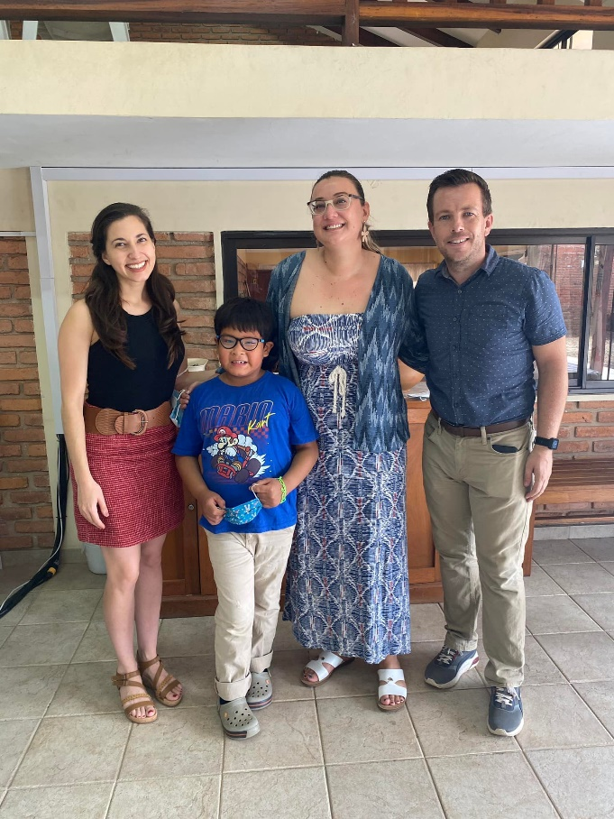 Craig is from Strathaven and Amanda is from Canada. They have been working as missionaries in Bolivia since 2010 and we have supported them since 2016.

Craig is currently the pastor of Trinity International Church. Amanda is coordinator for short term ‘Stride’ volunteers with Latin Link.

For various reasons Craig and Amanda have decided that the time is right to move to Canada. Craig is currently looking for a job as a pastor of a church. Amanda will move to work with Latin America Mission Canada (LAM Canada) in ‘Member Care’ which she can do from Canada. Member care has been defined as ‘the ongoing preparation, equipping and empowering of mission personnel for effective and sustainable life, ministry and work’, recognising that the physical, spiritual and mental care of the workers is essential. Amanda is passionate about this, having experienced severe burnout a few years ago.

There have been challenges helping Sam to socialise and cope with school which is part of the reason for the move to Canada. Craig and Amanda ask us to pray for wisdom and help as they parent for Sam.

Please pray

* for Amanda as she moves to her new job in Member Care
* for Craig as he aims to ‘finish well’ in Bolivia and looks for a job as a pastor in Canada
* for Sam as he has struggled with school in Bolivia. Pray that the move to Canada will be of benefit to him
* for Latin Link as they seek to replace Amanda’s post and for Trinity International church as they seek to fill the vacancy

**Jerry and Stacy Kramer,** **Love for the Least**

Andrew Robertson worked with Jerry and Stacy while he was in Zanzibar, and Burnside Blairbeth adopted them as missionary partners in 2016.

Jerry and Stacy have worked in the mission field since 2003. They joined YWAM in 2011 after which they set up ‘Love for the Least’ which focuses on least reached areas of the world, work with orphans, widows, refugees and addicts. They have worked in Nepal, Turkey, Zanzibar and Western Asia. Their current focus is a refugee camp in N Iraq with 1,000,000 refugees from ISIS and the Syrian Civil War. The average stay in a UN refugee camp globally is 18 years. They are also very involved in the orphanages they set up at 3 sites in E Africa where 400 orphans (from baby to college aged) are cared for. Twenty one of the orphans are currently in university.

Jerry and Stacy’s time is spent abroad visiting and directing the projects; and at home in the USA, gathering support and visiting supporting churches. We greatly inspired by a visit from Jerry and Stacy in August 2023 when they gave us further updates on their work. Further information can be found at <https://lovefortheleast.org/>

Please pray

* for transitioning the refugees from relief to long term recovery. This includes job skills and education. The UN provides no food so if they don’t work, they don’t eat
* for discipleship groups and churches in the Middle East to multiply. There are now >700 churches in Iran reaching the 8th generation, and more in Iraq.
* for local leaders to emerge and grow in discipleship, moving the Gospel forward.
* for people in the Middle East to have dreams and visions of Jesus. Thirty percent of Muslims following Jesus have had a dream or vision of Him.

**Janie Beattie, Barcelona**

**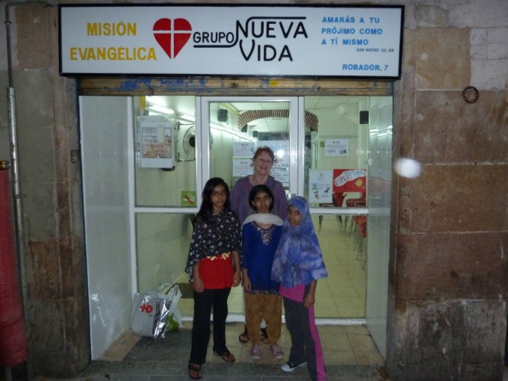**Janie first went to Spain in 1975 as she was keen to learn Spanish. She became a Christian in Spain and after returning to Burnside, with encouragement from Muriel Hamilton she joined Burnside Church. She then returned to Spain to attend a Seminary in Azuqueca de Henares for 3 years. Following this, Barcelona became her home and she taught English as a foreign language.

Janie has volunteered at the Evangelic Hospital for over 30 years, visiting patients and helping at the monthly Sunday service. Since covid the team have not been able to visit in the wards but have helped with arts and crafts at Christmas. Janie started volunteering at the local Mission about 30 years ago which is attended by children from deprived and broken families. Many of the children have suffered significant trauma in their lives. The mission runs camps and day trips for the children. There are local government activities running at the same time as the Mission and many children are going there instead as there is a financial incentive. In winter the Mission runs a street soup kitchen for those in need eg rough sleepers, drug addicts, prostitutes.

Please pray

* for wisdom to know what God wants the Mission team to do
* for more leaders to help with the Mission
* for the children’s hearts to be touched and healed by coming to faith in Jesus
* for health

**Please let Marjory know if you wish updates on any of our missionary partners** [**marjory.maclean@ntlworld.com**](mailto:marjory.maclean@ntlworld.com)